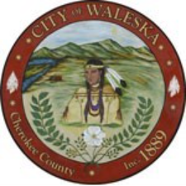
CITY OF WALESKA
Amended Agenda
Regular Meeting of the Mayor and Council
July 6, 2026

Item 1: Call to Order
Item 2: Invocation / Pledge of Allegiance
Item 3: Five Minute Public Input
Item 4 Consideration to Approve Regular Council Meeting Minutes – June 15, 2026
Item 5: Consideration to Approve the Called Meeting Minutes – June 23, 2026
Item 6: Public Hearing #1 – 2026 Tax Digest and Proposed FY2027 Millage Rate
Item 7: Yard of the Month
Item 8: Water System Report
Item 9: City Clerk’s Report
Item10: City Attorney’s Report
Item 11: Mayor’s Report
Item 12: Council Remarks
Item 13: Adjourn Regular Council Meeting
Item 14: Enter Executive Session
Item 15: Adjourn Executive Session
Item 16: Enter regular Council Meeting
Item 17: Adjourn Regular Council Meeting

