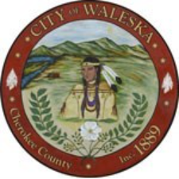
CITY OF WALESKA
Regular Meeting of the Mayor and Council
June 1, 2026

Item 1: Call to Order
Item 2: Invocation / Pledge of Allegiance
Item 3: Five Minute Public Input
Item 4 Consideration to Approve Regular Council Meeting Minutes – May 18, 2026
Item 5: America 250 Proclamation
Item 6: Consideration of Memorandum of Understanding with Cherokee County Emergency Management Agency for FEMA Integrated Public Alert and Warning System Emergency Alerting Services
Item 7: Water System Report
Item 8: City Clerk’s Report
Item 9: City Attorney’s Report
Item 10: Mayor’s Report
Item 11: Council Remarks
Item 12: Adjournment of Regular Council Meeting

